**PROJECT: 2**

***↪ Deploy static website on AWS***

**In this project, we will learn how to create a static website and deploy it using AWS services. A static website is a site that consists of HTML, CSS, and JavaScript files, and it doesn't require server-side processing or a database.**

**Table of Contents**

↪Project Overview

↪Objective

↪Technologies used

↪Website structure

↪Deploy on AWS S3

↪AWS

↪Conclusion

# project overview

# This project involves the development and deployment of a static website using HTML and CSS. The website has been hosted on Amazon Web Services (AWS) Simple Storage Service (S3), utilizing its static website hosting capabilities. The main goal of this project is to create a fast, reliable, and cost-efficient informational website with a professional UI and cloud-based availability.

# The deployment demonstrates the practical implementation of cloud computing fundamentals, web design, and DevOps basics by configuring S3 bucket permissions, static hosting settings, and public access policies. It also highlights the ability to in integrate core AWS services in a real-world

# Scenario

# ↪ Project flow diagram

[Start]

↓

[Website Design (HTML + CSS)]

↓

[Create AWS S3 Bucket]

↓

[Upload Website Files]

↓

[Set Bucket Policy for Public Access]

↓

[Enable Static Website Hosting]

↓

[Get Website URL & Test Deployment]

↓

[Project Completed]

# 2. Objective

↪The main objective of this project is to design, develop, and deploy a static website using HTML and CSS and host it on Amazon Web Services (AWS) Simple Storage Service (S3). This project aims to:

•Provide hands-on experience in static website creation.

•Understand the process of hosting a website using cloud services.

•Learn to configure S3 buckets for static hosting and public access.

•Apply cloud computing and web development concepts in a real-world scenario.

•Deliver a fast, secure, and cost-efficient deployment model without using a traditional web server.

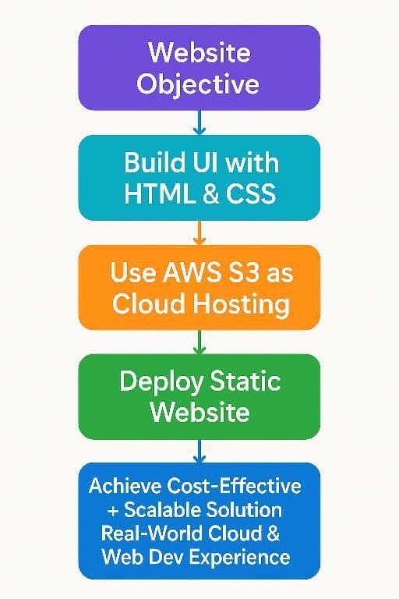

•Through this project, we aim to demonstrate how cloud platforms like AWS can be used to host scalable and easily accessible static websites efficiently.

# 3. Technologies used

↪This project was built using a combination of front-end web technologies and cloud services. HTML5 was used to structure the content of the web pages, ensuring a semantic and accessible layout. CSS was implemented to design and style the website, providing responsive behavior and a clean user interface.

For hosting, Amazon Web Services (AWS) Simple Storage Service (S3) was chosen due to its reliable, scalable, and cost-effective static website hosting features. The S3 bucket was configured to allow public read access using a customized bucket policy written in JSON format. To manage secure access and permissions, AWS Identity and Access Management (IAM) was utilized.

Finally, the website was tested and previewed across multiple modern browsers to ensure cross-platform compatibility and responsibility.

↪In short, Technologies used

•HTML

•CSS

• Amazon S3

•IAM

•Bucket policy

•Web Browser

# 4. Website structure

This project is a single-page static website developed using HTML and CSS. It contains multiple structured sections that explain various services of Amazon Web Services (AWS). The layout is clean, user-friendly, and informative.

**The website includes the following parts :**

1. Navigation bar

A menu at the top with links such as:

•Home

•About AWS

•WhatsApp

•Instagram

•Contact us

1. Introductory section

•What is AWS?

•Why do we use AWS?

•when use AWS?

1. AWS Service Section

•EC2

•S3

•Lambda

•SNS

•Cloudwatch

•VPC

1. Footer

• Group information

## 

# 5. Deploy on AWS S3

## 🚀 Deployment Process on AWS S3

## ↪ This section describes the step-by-step process followed to deploy the static website on Amazon Web Services (AWS) Simple Storage Service (S3). The goal was to host the website publicly using AWS cloud infrastructure.

## 🧩 Step-by-Step Deployment:

## Logged in to AWS Management Console.

## 🔹 Step 1: Create an S3 Bucket

## •Opened S3 Service from the AWS dashboard.

## •Clicked on “Create bucket”.

## •Gave a unique bucket name (eg. Demo-bucket).

## •Selected region (e.g., United states(N. Virginia ) ).

## •Unchecked “Block all public access” to allow website hosting.

## •Clicked Create bucket.

## 

## ↓

## 

## ↓

## 

## ↓

## 

## ↓

## 

## 🔹 Step 2: Upload Website Files

## Opened the created bucket.

## Clicked on “Upload” and added:

## AWS.html( upload file which have static website code)

## AWS.css

## Images file (Photos which we want to show in our static website )

## Clicked Upload to store files in the bucket

## 

## ↓

## 

## ↓

## 

## ↓

## 

## ↓

## 

## ↪All the required files are uploaded in s3 bucket …

## Step 3: Enable Static Website Hosting settings

## • To proceed, go to the S3 bucket name that you created and click on it. After that, navigate to

## the Properties tab which can be found at the top of the screen.

## • Scroll down to the Static website hosting section and click on Edit button.

## •In the Static website hosting dialog box

## Static website hosting: Select Enable

## Hosting type: Choose Host a static website

## Index document: Type *AWS.html*

## Error document: Type *error.html*

## Click on Save Changes.

## 

## ↓

## 

## Click on Save changes and all required steps are done just click on URL

## Now our website is sucessfully hosted on AWS

## 

## 

## 

## 

## 

## 

## 

## 

## 

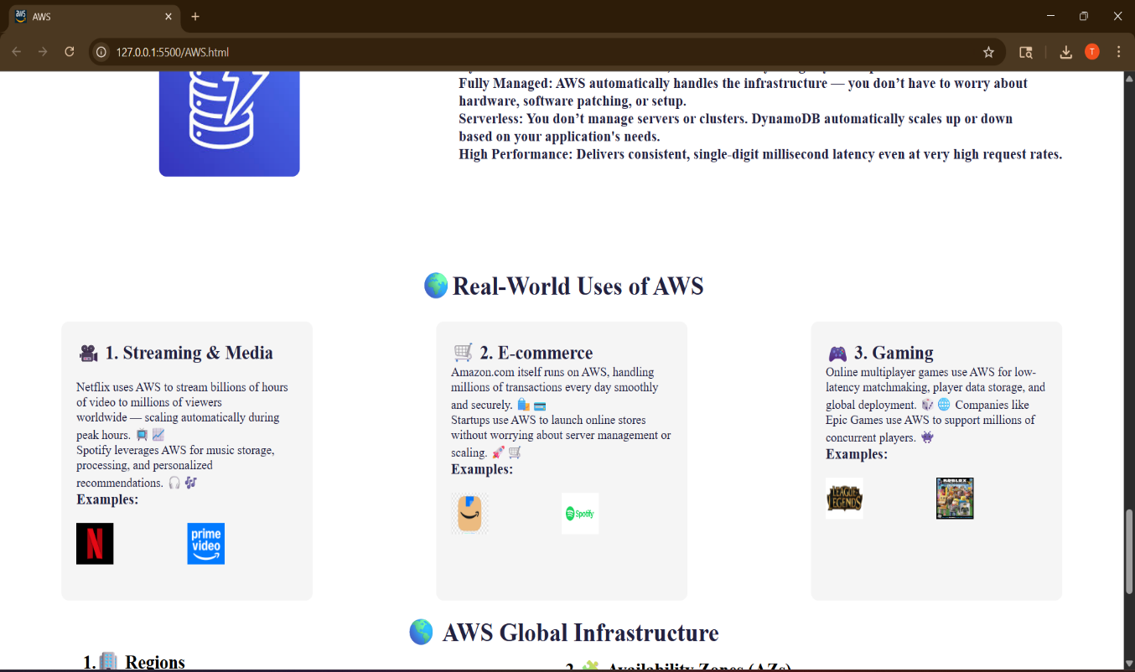

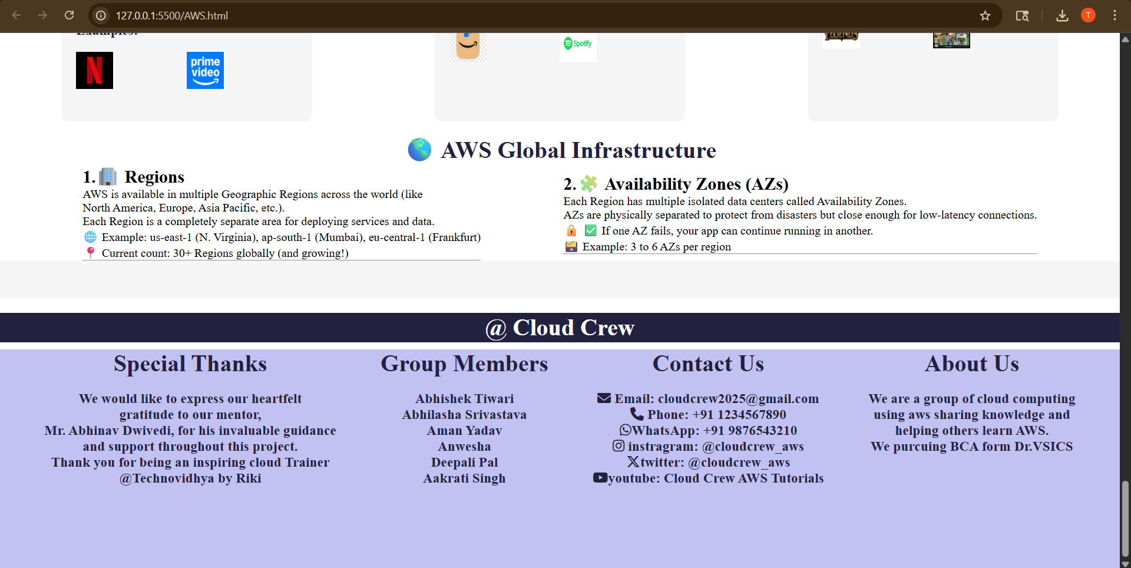

↪Our static website successfully hosted on AWS

AWS

AWS, which stands for Amazon Web Services, is a comprehensive cloud computing platform offered by Amazon. It provides a wide array of services, including computing power, storage, databases, and more, that businesses can access on-demand over the internet. Essentially, AWS allows companies to rent computing resources instead  of purchasing and maintaining their own physical infrastructure.

**On-Demand Services:**

AWS provides these resources on a pay-as-you-go basis, meaning businesses only pay for what they use, making it a cost-effective solution.

**Global Infrastructure:**

AWS has a vast network of data centers around the world, allowing businesses to deploy their applications closer to their users for faster performance and lower latency.

AWS Market

Amazon Web Services (AWS) is the market leader in cloud computing, holding a 32% market share. Microsoft Azure follows with a 23% market share, and Google Cloud Platform (GCP) holds 10%.

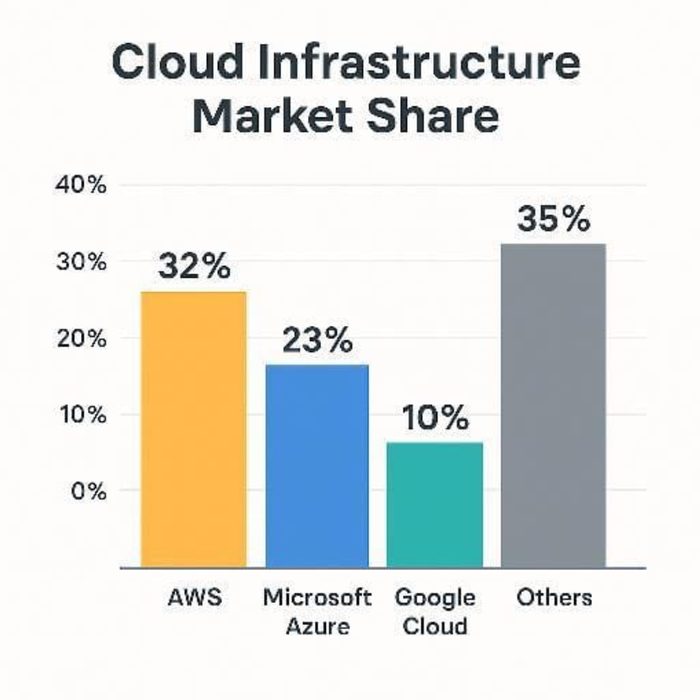

↪Major market owned by AWA

Conclusion

In this project, we successfully created and deployed a static website using Amazon Web Services (AWS), specifically by utilizing an S3 bucket for hosting. Through this process, we gained hands-on experience with AWS cloud infrastructure, including setting up S3 buckets, managing permissions, enabling static website hosting, and optionally configuring a custom domain.

This method of deployment is cost-effective, reliable, and scalable, making it ideal for hosting small to medium-sized websites. The project provided valuable practical knowledge of deploying websites without the need for traditional servers, which is a useful skill for both web development and DevOps roles.

Overall, the project helped reinforce our understanding of cloud services and gave us real-world deployment experience.

